**Classroom Activity: Deployment Render**

1. **Create an account in rendor.com(deploy)**

* Type <https://render.com/> in the browser to connect the rendor page.
* Click on the dashboard to register through Git Hub.

(note: GitHub with Repository is required)

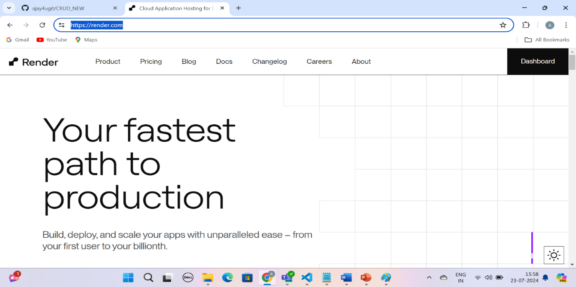

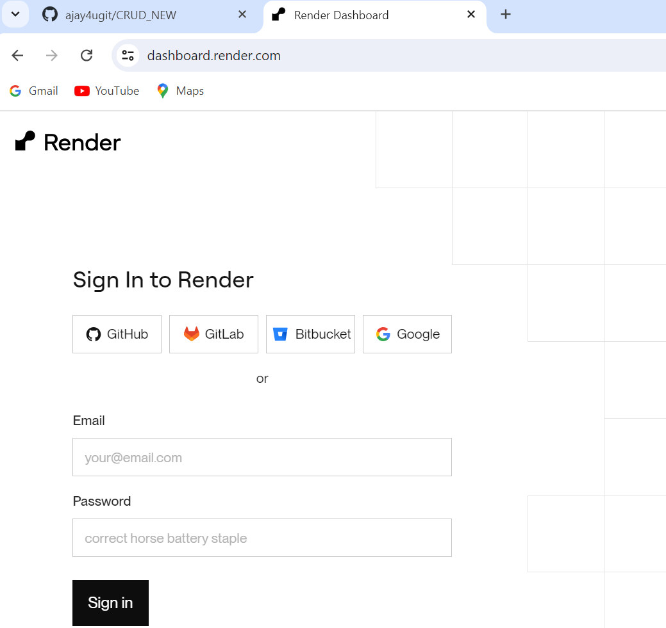

* click on the GitHub tab and enter credentials to enter into the render page.

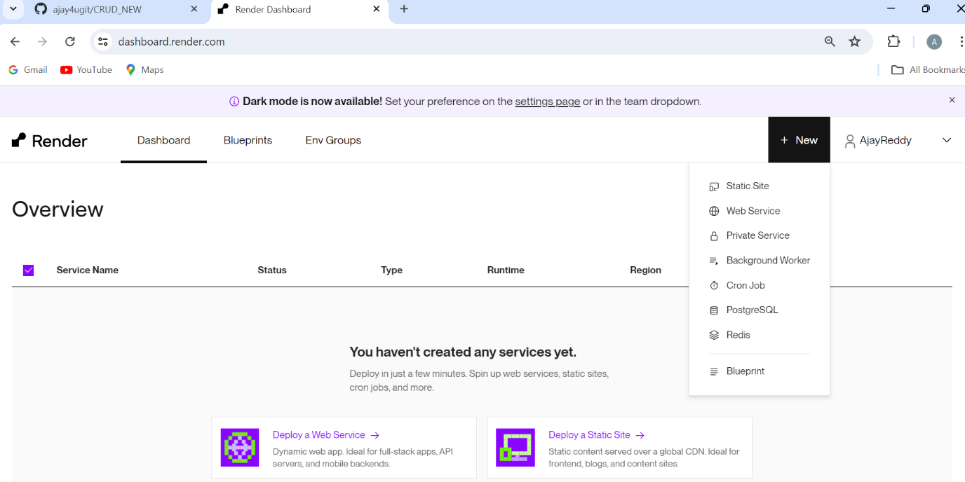

1. **Deploy the first backend application project**

* click on a new tab and select the second option “Web Service”

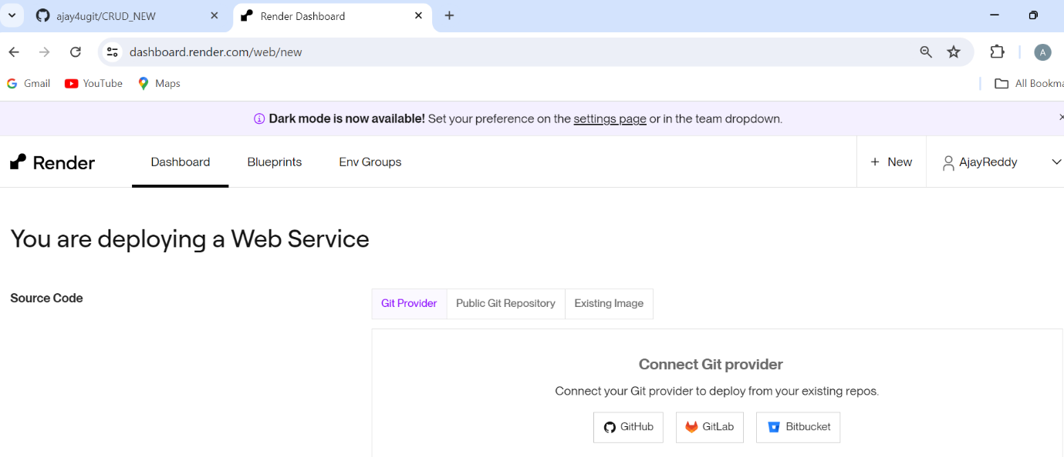

* click on again github button and select the radio button as only select repositories.

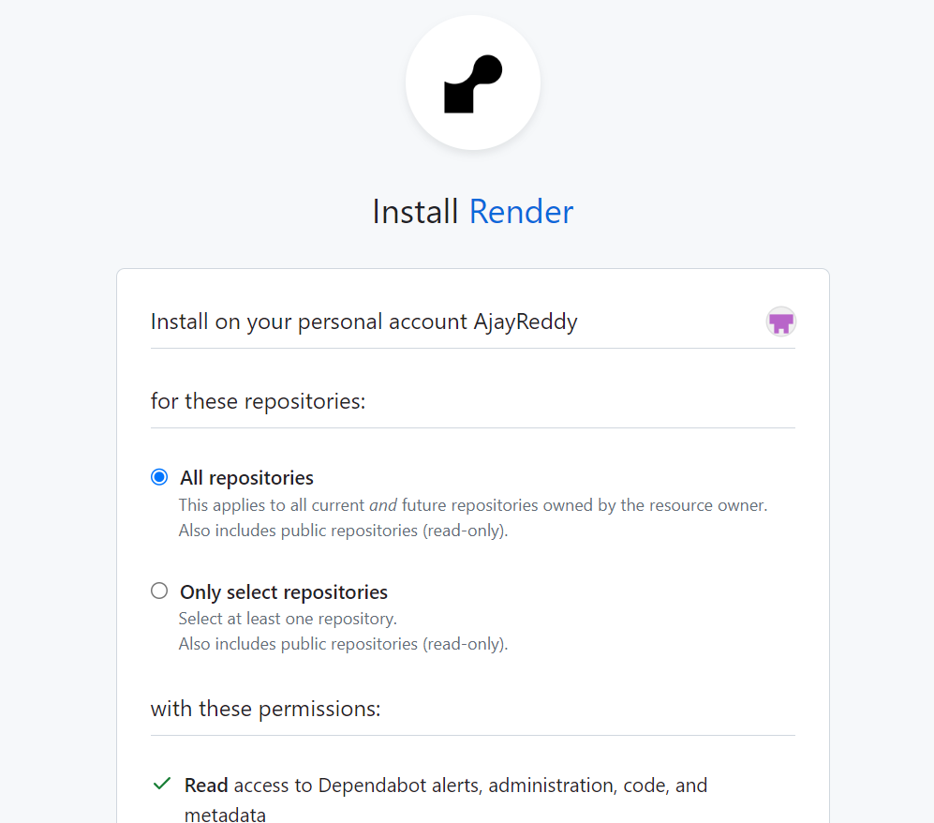

* select our repository and click on the install button to install

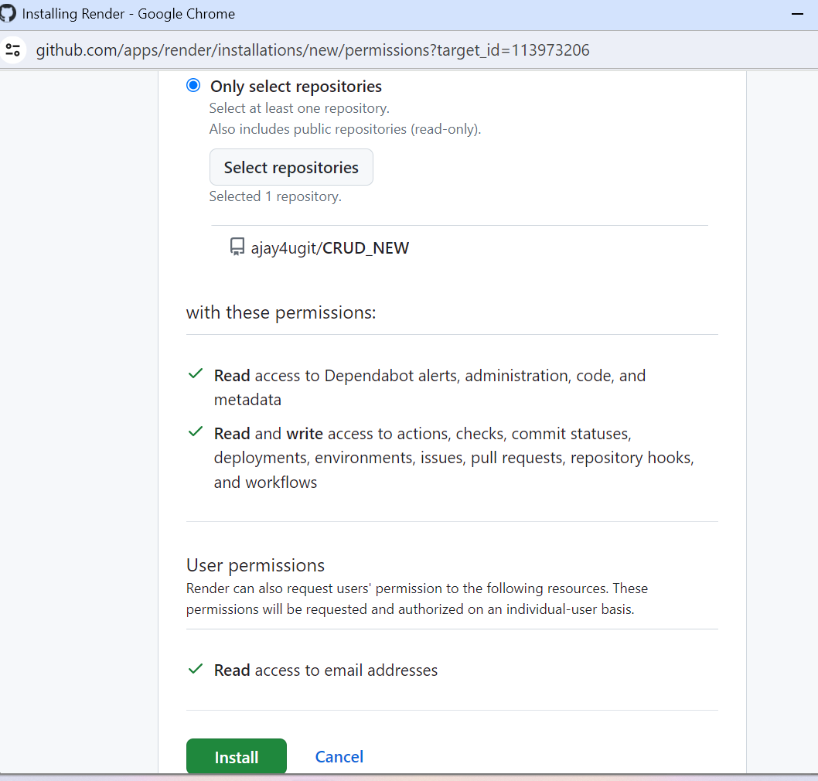

* select GitProvider tab select our repository and then click on the connect button.

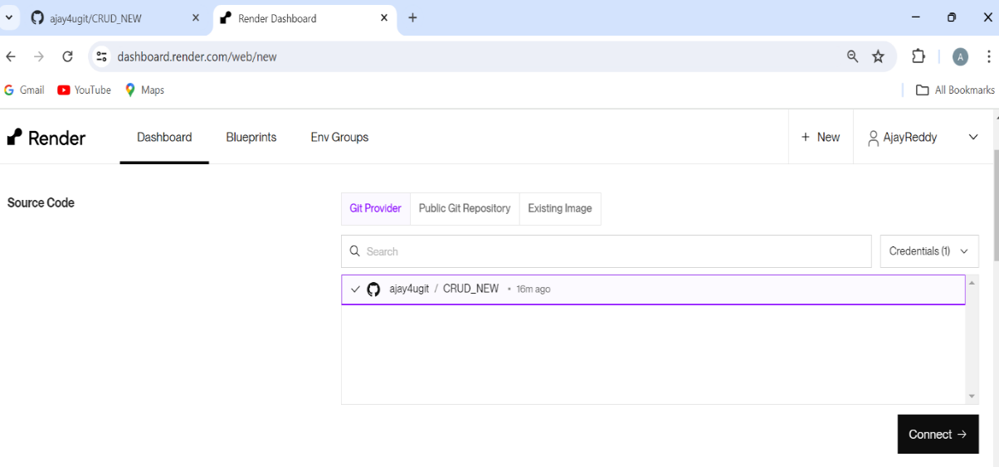

* Enter the name of the backend and enter root & build and start command, follow the same as the given below picture.

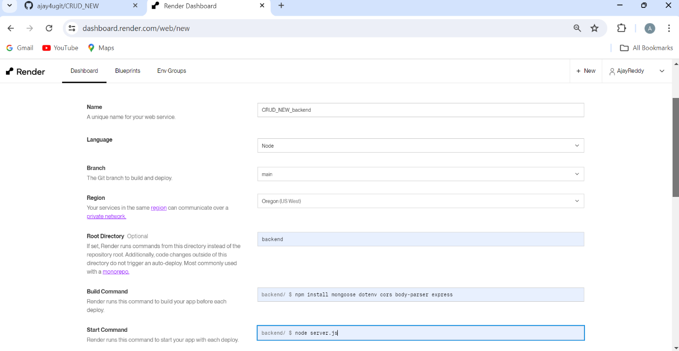

* select Free from instance Type.

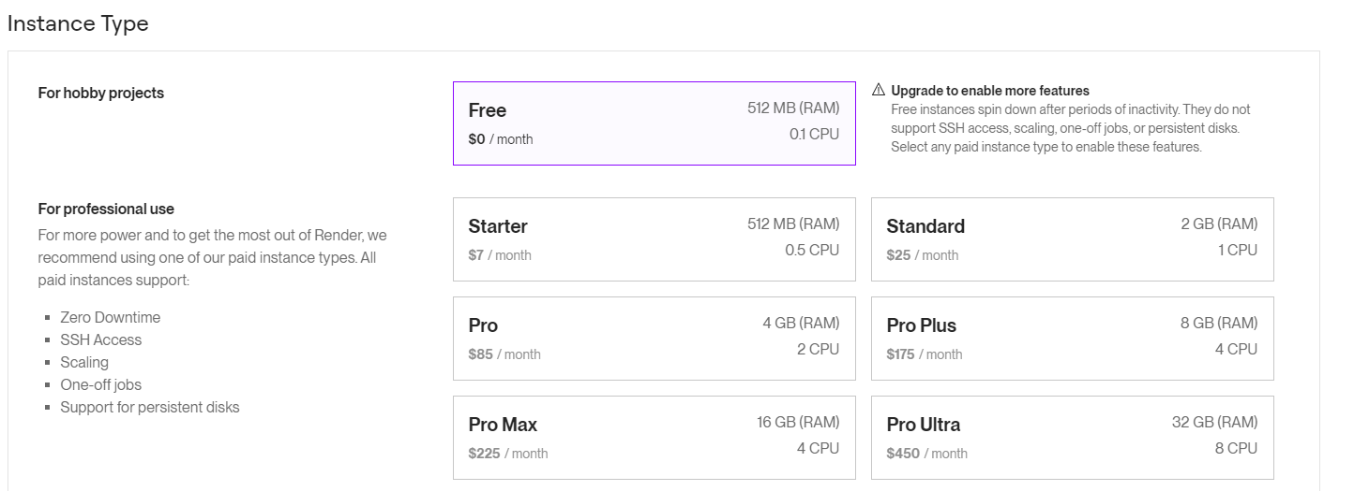

* Select Add from .env file

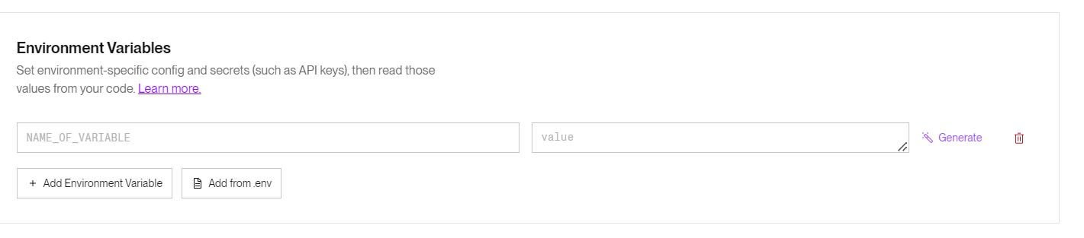

* Copy the data from the .env file from the backend directory and paste it inside of .env box here.

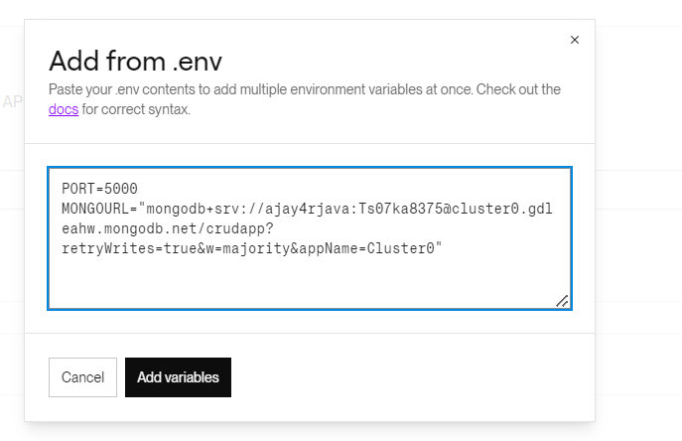

* click on the Add Variables button & finally click on the Deploy Web Service button

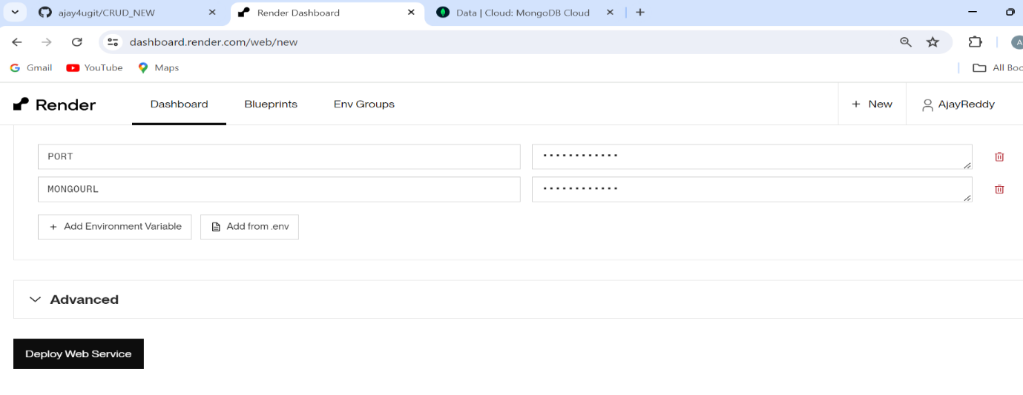

* Now find our backend project is deployed or not

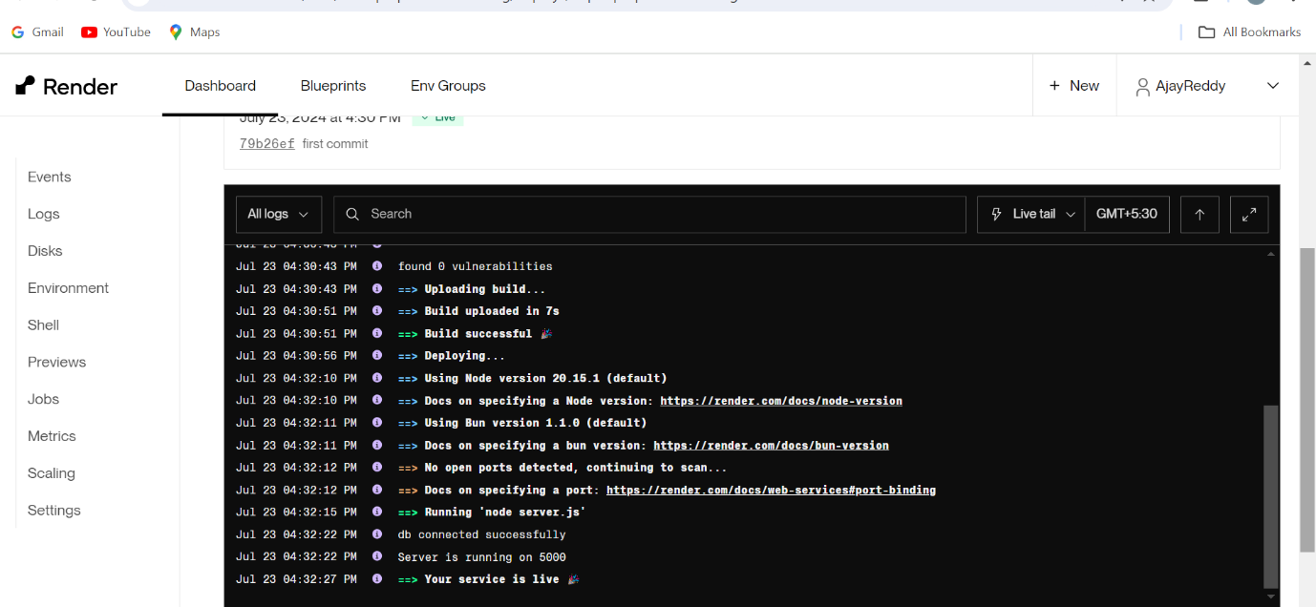

* Finally, our backend application is successfully deployed on the Render site.

1. **Add backend successful deploy URL in frontend code**

 The below picture shows the successful deploy URL link.

[https://crud-new-backend.onrender.com](https://crud-new-backend.onrender.com/)

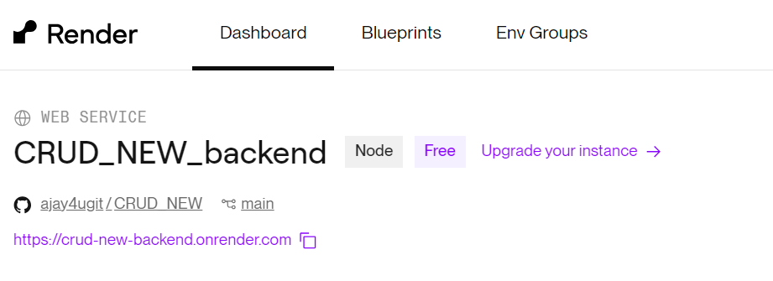

* goto frontend project and change url in Add.jsx

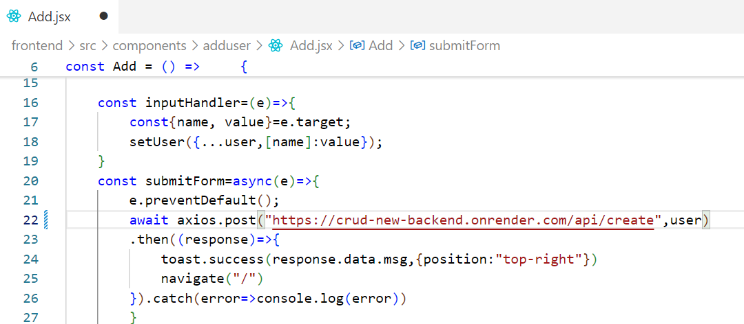

* change url in User.jsx

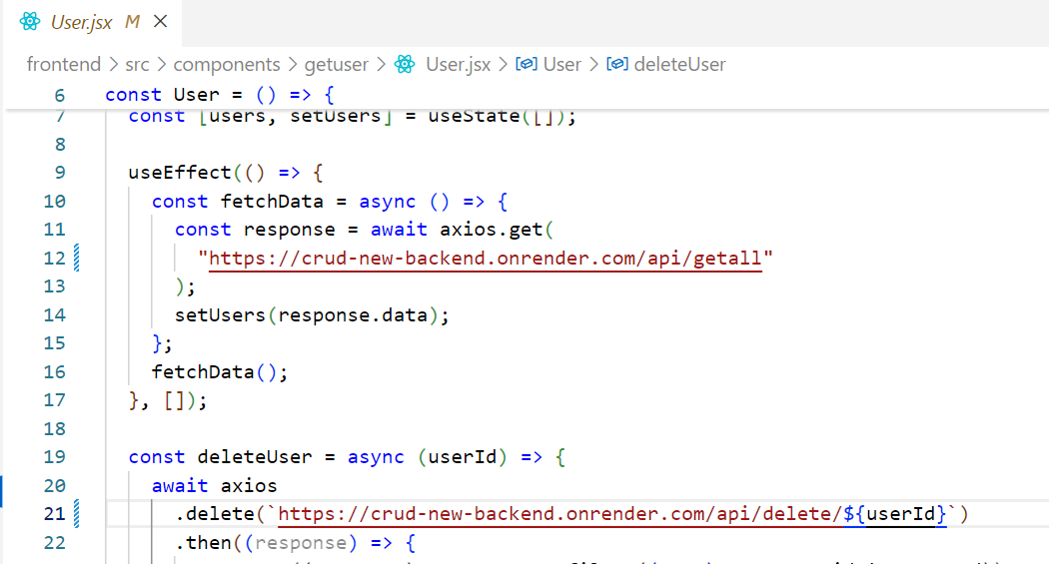

* change url in Edit.jsx file

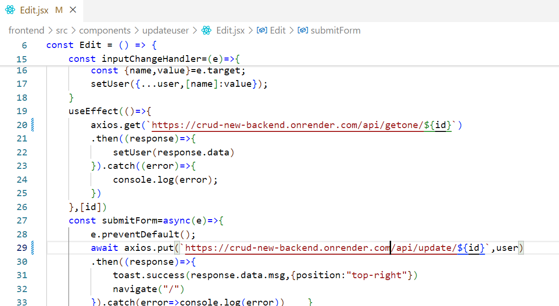

 now update changes need to be pushed into the GitHub repository again.

1. **Deploy frontend application project into Rendor.com**

* Click on new and select the second option as Web Service from Rendor.com

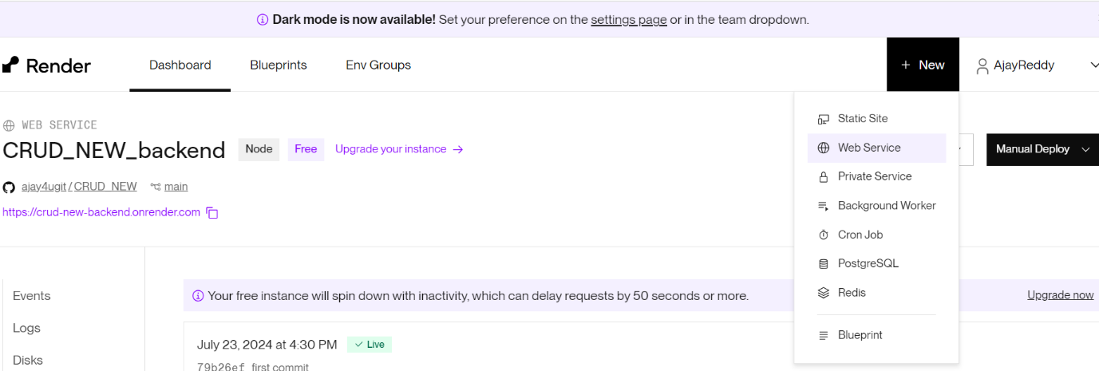

* select our repository and click on the connect button

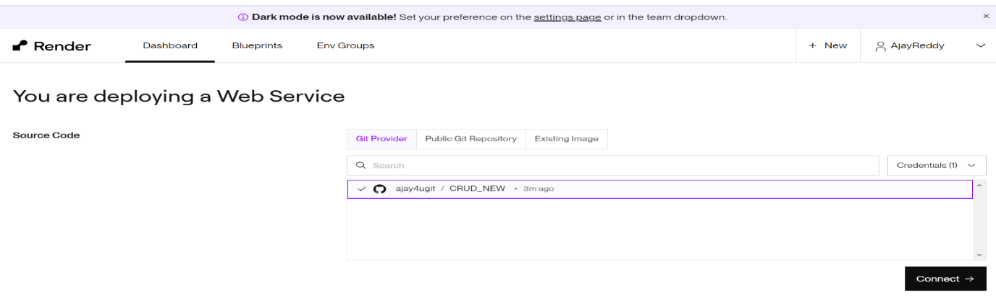

* enter the following  frontend details as given below

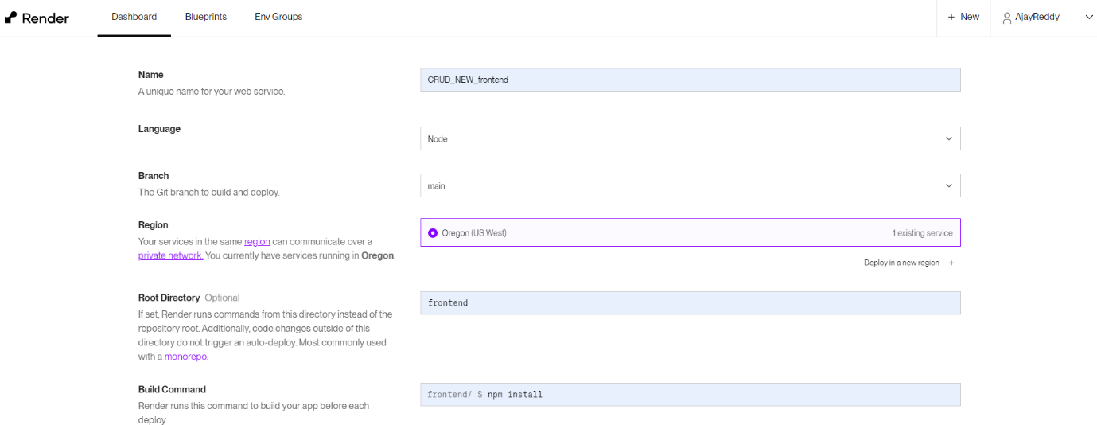

* finally , click on Deploy Web Service

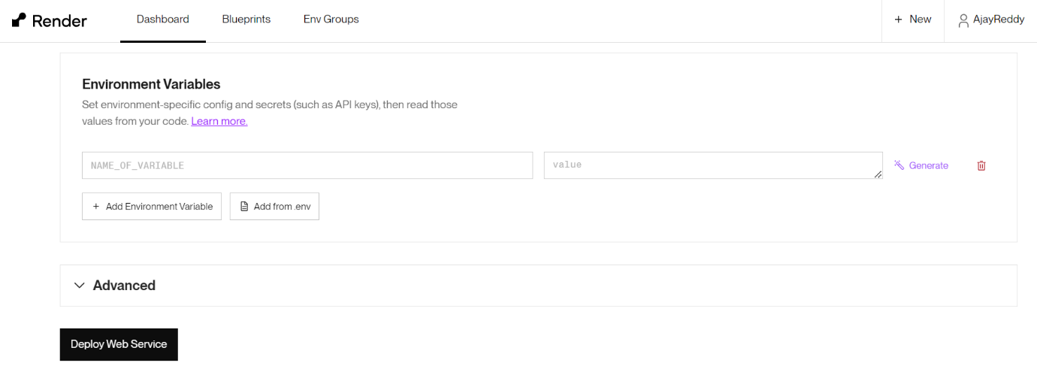

**5. Check frontend URL in the browser is working or not.**

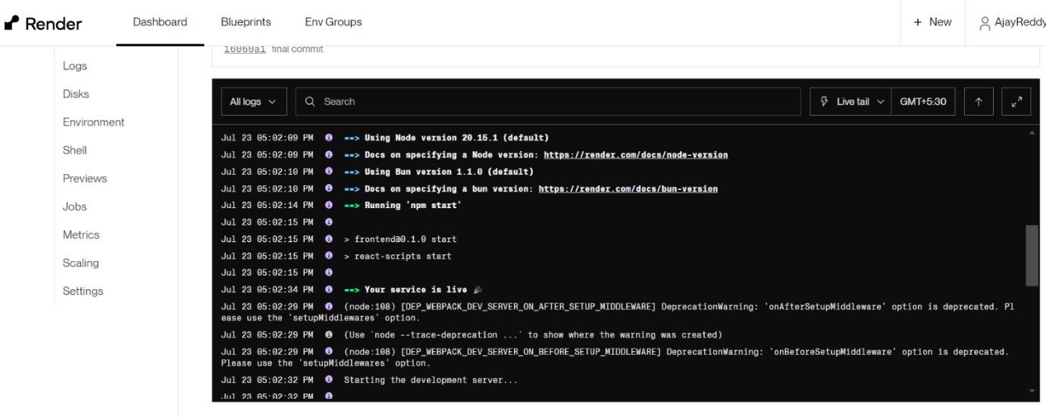

* After frontend project service is live and check both frontend and backend status is in Deployed mode.

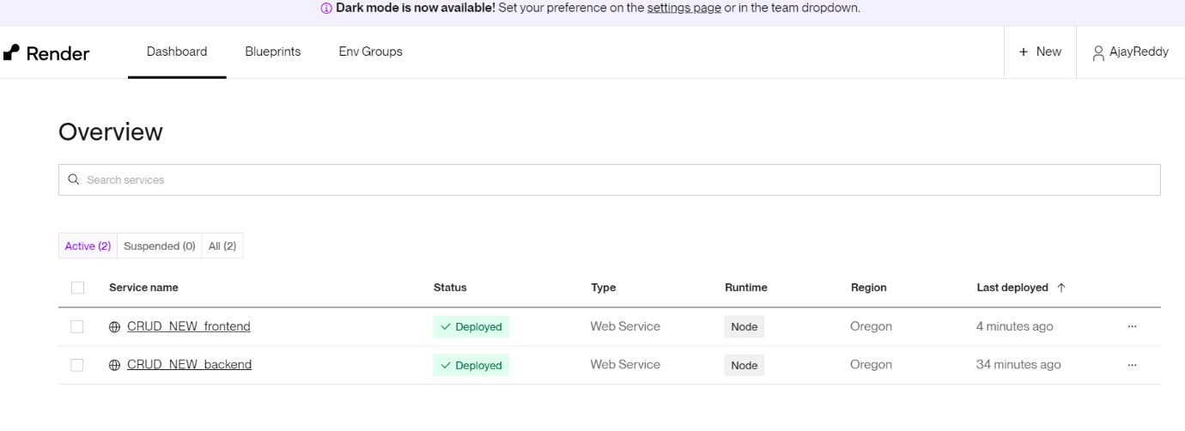

* Copy CRUD_NEW_frontend URL
* [https://crud-new-frontend.onrender.com](https://crud-new-frontend.onrender.com/)
* check on the browser